Rainbow Reiki is a system of spiritual healing based on Traditional Usui Reiki. But Rainbow Reiki has been constantly developed through research and the memories of past lives of Walter Lübeck. The 1. degree of Rainbow Reiki offers tremendous healing techniques and goes far beyond anything the Traditional Usui Reiki has to offer. Experienced masters of Traditional Usui Reiki will learn 98 % new content in a RR 1. degree class. RR is worldwide renowned as a first class spiritual healing art. $400

The program of the 1. degree of Rainbow Reiki (RR)
This class contains five partial initiations

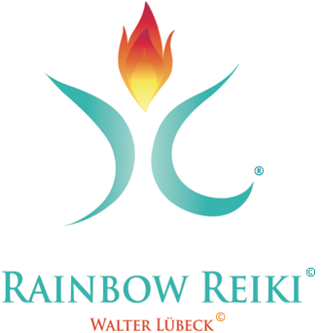
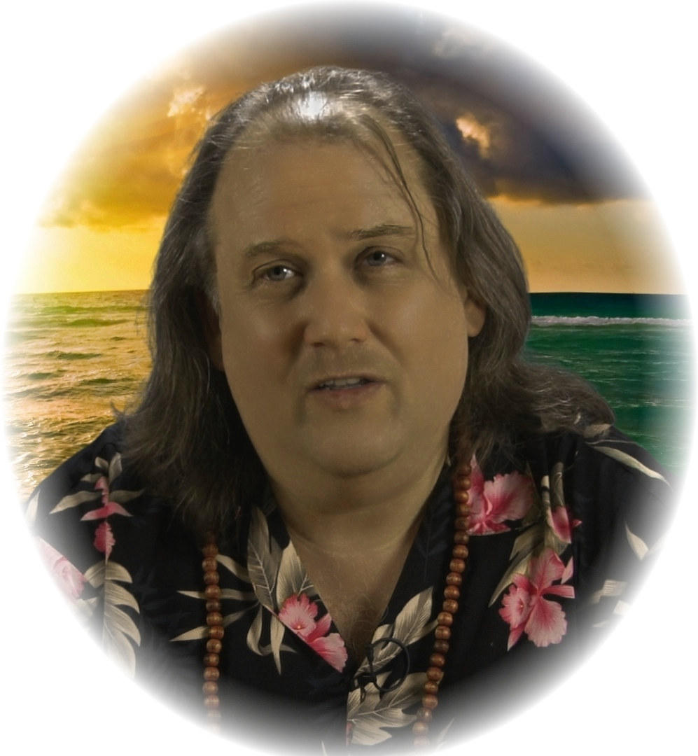
Everybody can participate - no requirements! The class comes with printed English manuals & certificate and an Audio CD with RR mantra performed by Walter Lübeck.
- The true history of Traditional Usui Reiki
- The original Five Usui Principles, as written down on the memorial stone besides Usui’s grave, their spiritual meaning and how to use them in ancient japanese language as mantras.
- The Five Healing Principles of Usui
- The Three RR Principles
- The original Gassho Meditation
- RR Meditation with crystals and aromatherapy
- The RR Whole Body Treatment with psychosomatic and spiritual background information
- Marayana Sayi - special RR Whole Body Treatment (see extra file „Marayana Sayi“ for details of this amazing new spiritual healing method!)
- Marayana Sayi Aurahealing (treating clients through visualization and special mantras with Marayana Sayi from a distance up to 30 meter!
- Systematical Chakra work
- Chakra balancing
- The Medicine Buddha-mantra (comes with initiation) and how to do proper mantra meditation
- Spiritual healing, blessing of food, beverages and cosmetics products with the blue light of the Medicine Buddha Yakushi Nyorai
- Special positions (stress relief; headache/ migraine; digestion; spine; shock; sciatic pain; fever)
- RR aura massage
- The two Usui treatment mudra
- The RR cure and a proper diet for healing
- A special Lemurian symbol with mantra to normalize the flow of energies and to promote proper circulation.
- The RR Enner Sense Technique for promoting the ability to sense Byosen (disharmonic energies), to do effective healing through reflex zones and to develop the personal Reiki healing power.
Walter Lübeck wrote 25 books. Eight books are about Reiki. The books are translated to more than 20 languages. Walter Lübeck teaches Reiki since 1989, is Master/Teacher of Traditional Usui Reiki, founder and Grandmaster of Rainbow Reiki and Shihan-Kaku of Jikkiden Reiki. He traveled Japan, Hongkong, Bali and India doing research about Usui Reiki and its roots. He works together with other internationally Reiki masters like William Lee Rand and Arjava Petter in writing books, giving classes and doing research. In spring 2012 he took part in a scientific research project with Dr. Ignat Ignatov from Bulgaria about his psychic healing and Reiki talents with excellent results (see here:http://www.rainbowreiki.de/rainbow-reiki-forschung.html).
Rainbow Reiki is a registered trademark of Walter Lübeck
Marayana Sayi and Walter Lübeck are registered trademarks of Walter Lübeck.
This class will be offered in February 27, 28, 2015
Organizer: Debbie Wetzel - Reiki Alternative Care
Email: Website http://www.reikialternativecare.com
Phone: 724-974-9249

